

Structural Design

(Inside View)

**Vertical corrugation**

 12 

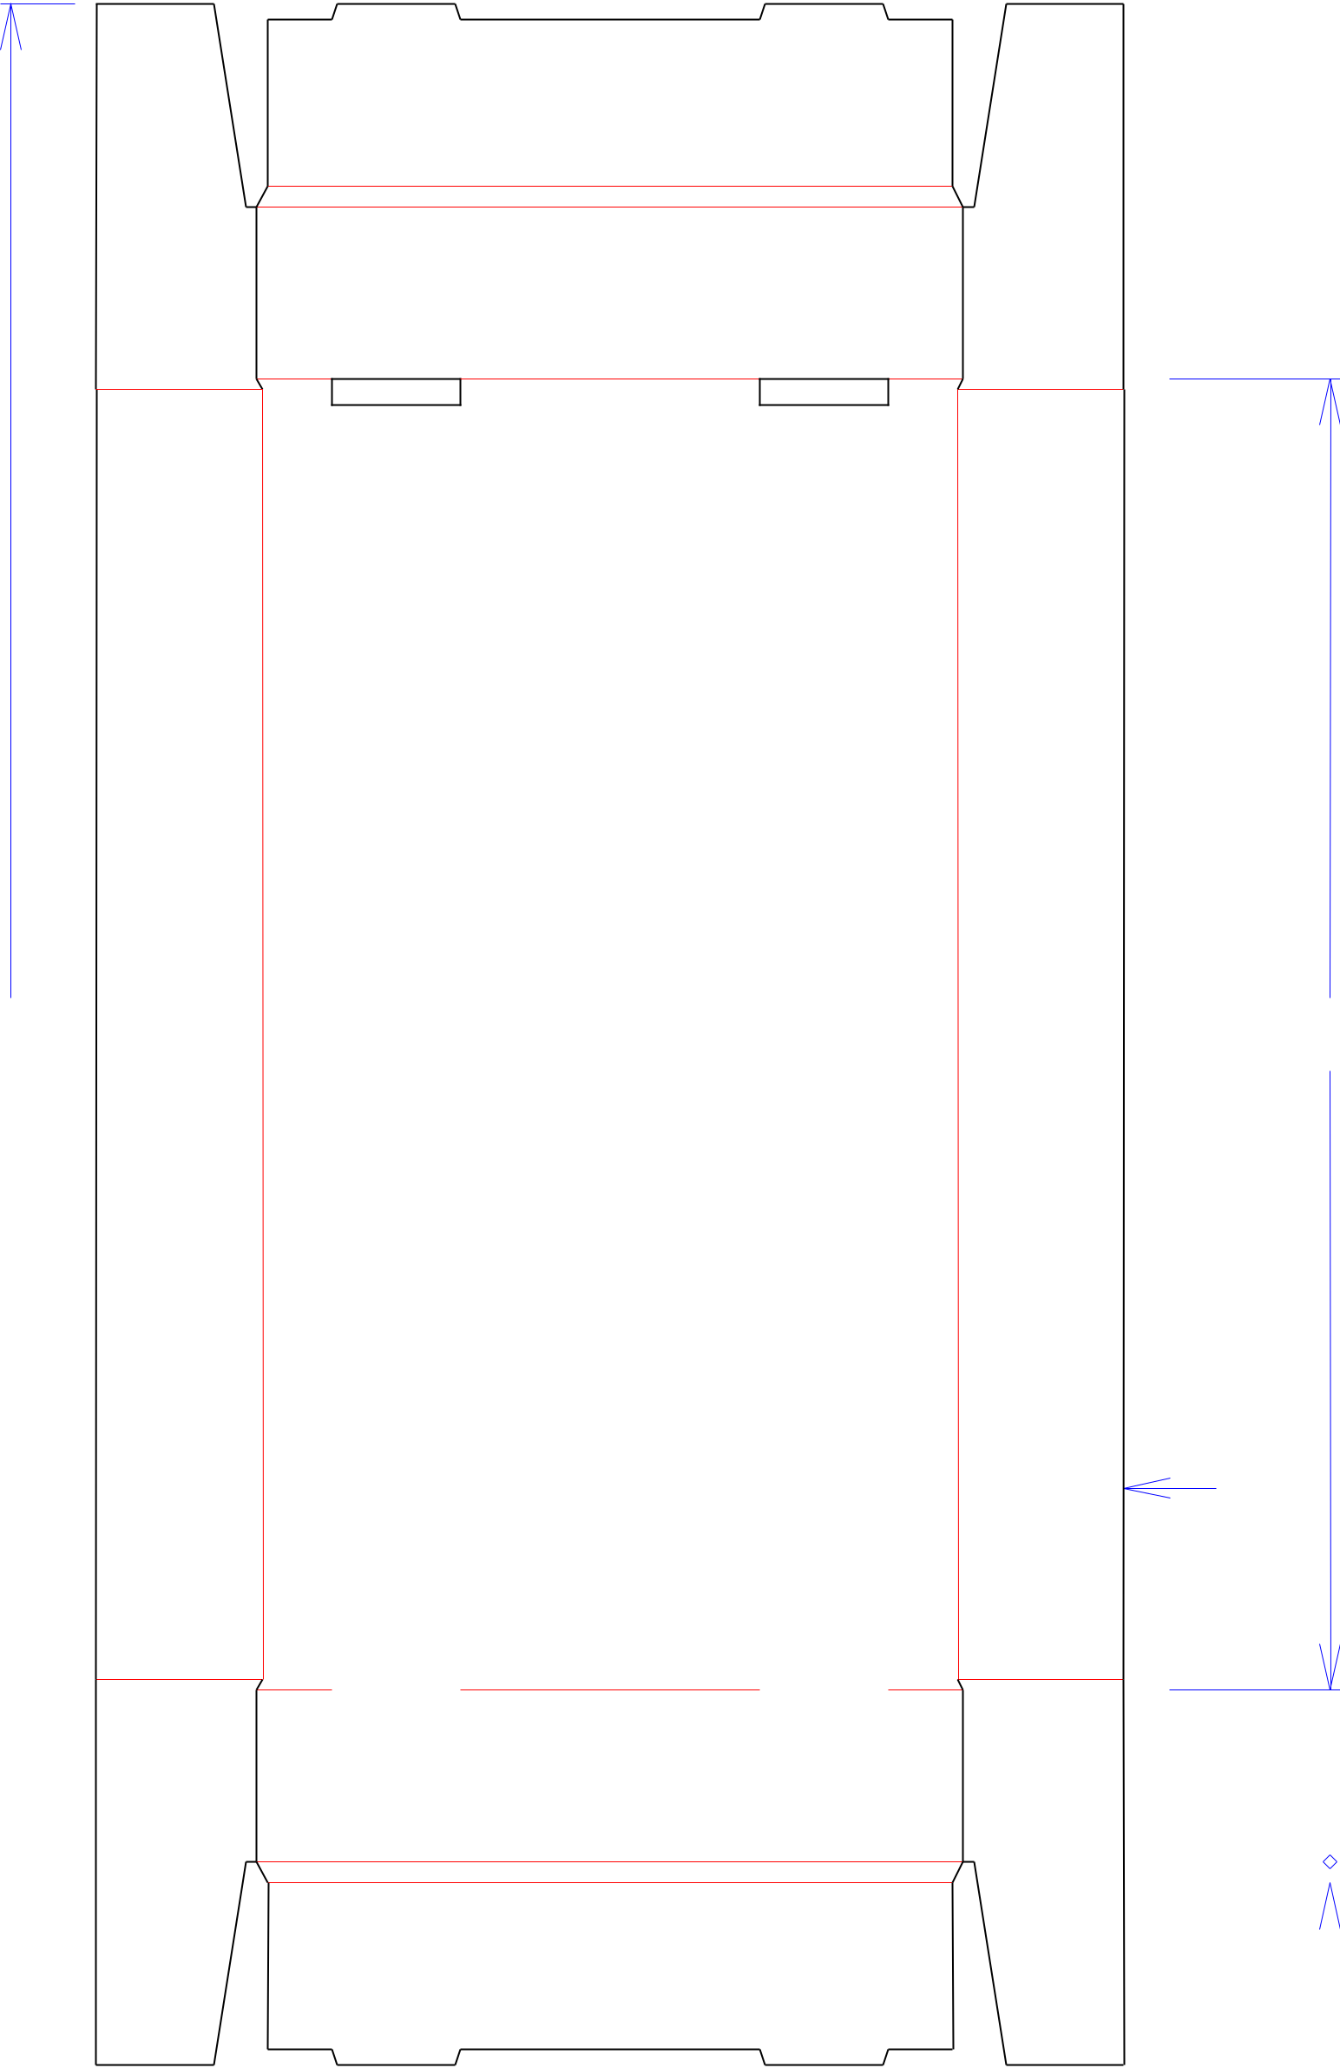

241*/*16 155*/*16



Design#:

**180659-01**

Customer:

**DeMet's Candy**

Description:

**TRAY - Turtles VDAY 2019-6pc**

**Heart-Walgreens-1 facing by 6 deep**

**[9001185]**

**SINGLE-OUT DRAWING**

Qty/Unit:

Style: **NJDC**

Board: **32BW**

Combination: **36MW - 23M - 35HP**

I.D. : **14+11/16 x 8 x 2**

Area of Blank - Waste : **1.95 sq. ft.**

Waste on Blank : **2.73%**

Finished Piece Weight: **0.20 lbs./92.73g**

Over-all Blank: **24+1/16 x 12**

 81*/*8  115*/*16

Notes:

|  |  |  |  |  |  |  |  |  |  |  |  |  |  |  |  |  |  |  |  |  |  |  |
| --- | --- | --- | --- | --- | --- | --- | --- | --- | --- | --- | --- | --- | --- | --- | --- | --- | --- | --- | --- | --- | --- | --- |
|  |  |  |  |  |  |  |  |  |  | 2 | | |  |  |  |  |  |  |  |  |  |  |
|  |  |  |  |  |  |  |  |  |  |  |  |  |  |  |  |  |  |  |  |
|  |  |  |  |  |  |  |  |  |  |  |  |  |  |  |  |  |  |  |  |
|  |  |  |  |  |  |  |  |  |  |  |  |  |  |  |  |  |  |  |  | Revision Info: | **[0] 05/11/2018** |  |
|  |  |  |  |  |  |  |  |  |  |  |  |  |  |  |  |  |  |  |  |  |
|  |  |  |  |  |  |  |  |  |  |  |  |  |  |  |  |  |  |  |  |  |
|  |  |  |  |  |  |  |  |  |  |  |  |  |  |  |  |  |  |  |  |  |  |  |
|  |  |  |  |  |  |  |  |  |  | 1*/* | 4 | |  |  |  |  |  |  |  |  |  |  |
|  |  |  |  |  |  |  |  |  |  |  |  |  |  |  |  |  | Designer: | **Alan Groff** |  |
|  |  |  |  |  |  |  |  |  |  |  |  |  |  |  |  |  |  |  |  |  |
| Cut | Crease | | Crease with Matrix | | | Cut Crease | | Half Knife Cut | |  |  | Tear Tape | | | | | | | Perforation | |  |  |
|  |  |  |  |  |  |  |  |  |  |  |  |  |  |  |  |  |  |  |  |  |  |  |



Designright and Copyright of DS Smith Corrugated Packaging Ltd. This technical Specification is subject to Manufacturing tolerances. Drawing dimensions shown are crease to crease. Date printed: 09/12/2018